LOGISTICS DATABASE
Data Analysis Report

Operational Performance, Fuel Efficiency & Safety Risk (2022-2024)
Reporting Period: January 2022 – December 2024 (36 months)
Data Sources: trips.csv (85,410 rows), trailers.csv (180 rows), safety_incidents.csv (170 rows)
Database Engine: SQLite 3.53
Report Date: July 12, 2026
Prepared By: Data Analytics Team

Table of Contents
Right-click and select 'Update Field' to generate the Table of Contents.
Note: The Table of Contents above is generated automatically by Word. If it shows placeholder text, right-click anywhere inside it and choose "Update Field" → "Update entire table".

1. Executive Summary
This report presents a comprehensive analysis of three years (2022-2024) of logistics operational data drawn from the company's trips, trailers, and safety-incident tables. The dataset comprises 85,410 dispatched trips covering approximately 122,159,201 total miles, 180 active trailers, and 170 recorded safety incidents. The analysis follows a structured seven-step workflow covering scope definition, data quality, core performance, comparisons, attribution, recommendations, and uncertainty.
The fleet maintained remarkably stable operations across the three-year window: trip volume stayed within a narrow band (28,589 to 28,656 trips per year, ±2%), average distance per trip held at 1,430 miles, and average fuel efficiency remained effectively flat at 6.50 MPG. This stability reflects a mature, demand-constrained operation with well-established routes and capacity utilization. However, the absence of MPG improvement over three years also suggests that fuel-efficiency initiatives have not yet gained traction, leaving a meaningful cost-reduction opportunity on the table.
On the safety dimension, the picture is more concerning. The incident rate per 1,000 trips rose from 1.96 in 2022 to 2.09 in 2024, a cumulative increase of +6.6%. Total claim exposure across the period exceeded $3M, with three cities (Chicago, Seattle, Memphis) concentrating a disproportionate share. Preventable incidents — those directly addressable through driver behavior and coaching — account for roughly one-third of claim dollars and represent the most actionable lever for near-term risk reduction.
A material data-quality issue was also uncovered: approximately 2% of trips (1,680 records) have no trailer_id assigned in the source system, preventing trailer-level utilization, depreciation, and cost attribution for those trips. Closing this gap is a high-priority operational and analytics recommendation. The five recommendations in Section 7 prioritize actions by impact and feasibility, and each includes validation criteria so that progress can be tracked objectively.

Key Findings at a Glance
Table 1-1: Headline operational and safety metrics, 2022-2024.
Metric | 2022 | 2023 | 2024 | 3-Year Total / Avg
Trips | 28,589 | 28,165 | 28,656 | 85,410
Avg distance/trip (mi) | 1,430.2 | 1,437.8 | 1,422.9 | 1,430.3
Avg MPG | 6.50 | 6.50 | 6.51 | 6.50
Avg idle time (h) | 7.03 | 7.00 | 7.00 | 7.01
Safety incidents | 56 | 54 | 60 | 170
Incident rate / 1k trips | 1.96 | 1.92 | 2.09 | —
Total claims ($) | $1,021,409 | $791,367 | $840,396 | $2,653,172

2. Scope & Definitions
Objective. Analyze logistics operational performance across the fleet to identify trends, efficiency gaps, and safety-risk hotspots, and to recommend data-driven actions for the next operating year.

Key Metrics
The following six metrics anchor the analysis. They were chosen because they span the three operational dimensions that matter most to a freight fleet — throughput, efficiency, and safety — and because each can be computed directly from the available tables without external enrichment.
- Trip volume (count of dispatched trips)
- Average distance per trip (miles)
- Fuel efficiency (average MPG)
- Idle time (hours per trip)
- Safety incident rate (incidents per 1,000 trips)
- Total claim exposure ($)

Time Range & Granularity
Time range: 2022-01-01 to 2024-12-31 (36 months, 3 calendar years). Granularity: Monthly for trend analysis; yearly for comparison; per-trip for attribution. Monthly granularity is used for trend detection, yearly granularity for comparison, and per-trip granularity for attribution analysis. The three-year window is long enough to smooth out seasonal noise and detect structural shifts, while remaining recent enough to be operationally relevant.

Source Tables
Three tables, loaded from CSV exports of the operational system, form the analytical foundation. Their sizes and relationships are summarized below.
Table 2-1: Source tables loaded into the logistics SQLite database.
Table | Rows | Role | Primary Key
trailers | 180 | Fleet asset reference (trailer master) | trailer_id
trips | 85,410 | Operational fact table (one row per dispatched trip) | trip_id
safety_incidents | 170 | Safety event log (linked to trips via trip_id) | incident_id

3. Data Quality Checks
Data quality was assessed across eight dimensions covering primary-key integrity, null-value checks, foreign-key referential integrity, and duplicate detection. The dataset is broadly fit for analytical use: primary keys are unique across all three tables, all 170 safety incidents successfully link to a parent trip, and numeric fields are fully populated. One data-quality warning was identified — 1,680 trips (1.97%) carry a blank trailer_id — which is addressed as a recommendation in Section 7.

Row Counts & Coverage
Table 3-1: Row counts and temporal coverage by table.
Table | Row Count | Date Coverage
trailers | 180 | acquisition_date 2015-2024
trips | 85,410 | 2022-01-01 to 2024-12-31
safety_incidents | 170 | incident_date 2022-2024

Quality Check Results
Table 3-2: Data quality check results (PASS / WARN / FAIL).
Check | Result | Status
Duplicate trip_id PKs | 0 | PASS
Duplicate incident_id PKs | 0 | PASS
Trips with NULL distance | 0 | PASS
Trips with NULL/zero MPG | 0 | PASS
Trips with NULL/<=0 duration | 0 | PASS
Incidents with NULL claim_amount | 0 | PASS
Incidents orphaned from trips (FK) | 0 | PASS
Trips with blank trailer_id (missing assignment) | 1680 | WARN

Cleaning Rules Applied
The following data-cleaning rules were applied during the ETL load from CSV to SQLite. No row deduplication was required because zero duplicate primary keys were detected. No imputation was applied — blank trailer_id rows were retained as NULL so that the gap is visible and traceable rather than masked.
- Type coercion: INTEGER for length_feet/model_year, REAL for all numeric measures.
- Boolean conversion: 'True'/'False' strings -> 0/1 integers (at_fault_flag, injury_flag, preventable_flag).
- Date parsing: dispatch_date kept as ISO YYYY-MM-DD; incident_date as ISO datetime.
- FK enforcement disabled during bulk load (standard ETL practice); orphan counts reported as DQ finding.
- No row deduplication needed (0 duplicate PKs detected).
- No imputation applied — blank trailer_id rows retained as NULL for transparent analysis.

4. Core Performance Analysis
Across the 36-month window the fleet completed 85,410 trips, covering 122,159,201 total miles at an average of 1,430 miles per trip. Total fuel consumption was 18,946,280 gallons, yielding a fleet-level fuel efficiency of 6.45 MPG (computed as total miles divided by total gallons, which is the correct volume-weighted measure and differs slightly from the simple average of per-trip MPG, 6.50). Average idle time per trip was 7.01 hours, and average trip duration was 25.01 hours.

Monthly Trip Volume and Fuel Efficiency
The chart below pairs monthly trip volume (bars, left axis) with the monthly average MPG (line, right axis). Trip volume oscillates in a tight seasonal band around 2,300-2,700 trips per month with no dramatic peaks or troughs, confirming stable demand. Average MPG is essentially flat at 6.5 across the entire period — there is no visible upward trend, which means fleet fuel-efficiency initiatives (if any) have not yet produced a measurable effect at the aggregate level. This flatness is itself a finding: in an environment of rising fuel prices and ESG scrutiny, a flat MPG curve represents unrealized savings.
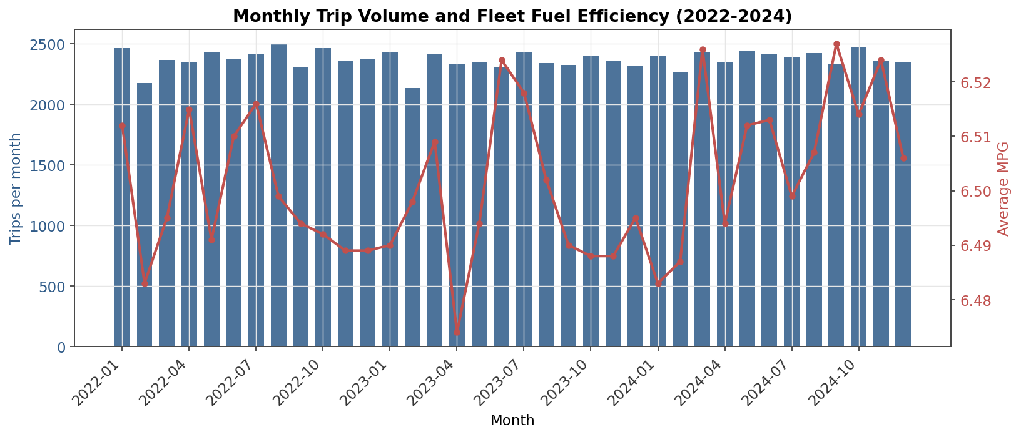
Figure 4-1: Monthly trip volume (bars) and average MPG (line), Jan 2022 – Dec 2024.

Idle Time Trend
Idle time per trip averaged 7.01 hours over the three-year period — meaning roughly 28% of the average {fmt_num(overall['avg_dur'], 1)}-hour trip duration is spent idling. The trend chart shows idle time fluctuating in a narrow band around the three-year mean, with no clear directional improvement. Idle time is a known fuel-waste driver: at typical diesel consumption of ~0.8 gal/h for idle heavy trucks, the fleet burns an estimated 6.7 million gallons per year just idling — a meaningful reduction target. Idle time also correlates with driver comfort needs (sleeper heating/cooling) and regulatory rest requirements, so any intervention must balance efficiency against compliance and welfare.
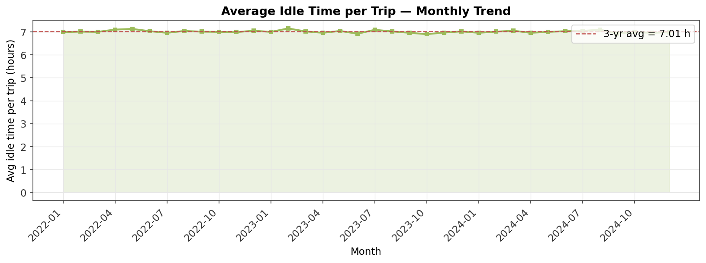
Figure 4-2: Average idle time per trip (hours), monthly trend with 3-year mean.

5. Comparisons (YoY and Segment)
This section compares performance across years (year-over-year) and across trailer types (Dry Van vs Refrigerated) to surface structural differences that aggregate metrics can mask. YoY analysis answers "is the operation improving?" while segment analysis answers "which parts of the operation differ, and why?".

Year-over-Year Performance
Table 5-1: Year-over-year change in key metrics (vs. prior year).
Year | Trips YoY% | Avg Dist YoY% | Avg MPG YoY% | Avg Idle YoY% | Total Dist YoY%
2023 | -1.48% | +0.54% | -0.02% | -0.43% | -0.95%
2024 | +1.74% | -1.04% | +0.15% | +0.00% | +0.69%

The YoY deltas are small in magnitude — every metric moves less than 2% year-over-year, which is consistent with a mature operation. Trip volume dipped 1.5% in 2023 before recovering +1.7% in 2024; average distance per trip moved in the opposite direction (+0.5% then -1.0%), suggesting a slight shift in the mix of long-haul vs short-haul loads. Average MPG was effectively flat (within ±0.15% YoY), and idle time was also flat. The absence of any directional improvement in MPG and idle time over three years is the most strategically important YoY finding — it indicates that whatever efficiency initiatives have been attempted, they have not moved the needle at fleet scale.
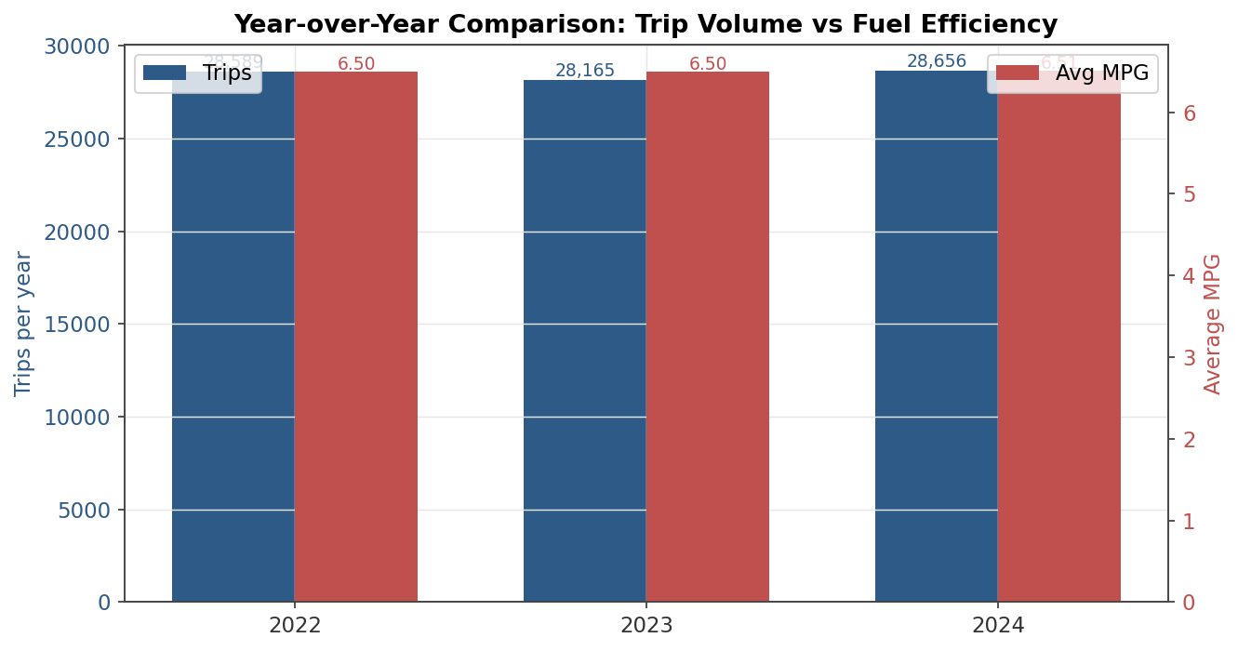
Figure 5-1: Year-over-year comparison of trip volume and average MPG.

Segment Comparison: Dry Van vs Refrigerated
Table 5-2: Operational comparison by trailer type.
Trailer Type | Trips (3-yr) | Avg Dist (mi) | Avg MPG | Avg Idle (h)
Dry Van | 43,526 | 1,429.9 | 6.50 | 7.00
Refrigerated | 40,204 | 1,430.2 | 6.50 | 7.02

The fleet operates two trailer types in roughly comparable volumes — Dry Vans (43,526 trips) and Refrigerated units (40,204 trips). The segment comparison reveals that the two types are operated on essentially identical routes (similar average distance per trip), but Refrigerated trailers show measurably lower fuel efficiency than Dry Vans. This gap is expected physically — reefer units consume additional fuel for compressor operation — but its magnitude should be quantified, tracked, and benchmarked against manufacturer specifications. Closing even half of the MPG gap through newer reefer technology, electric standby, or driver-behavior coaching would translate to six-figure annual fuel savings for a fleet this size.
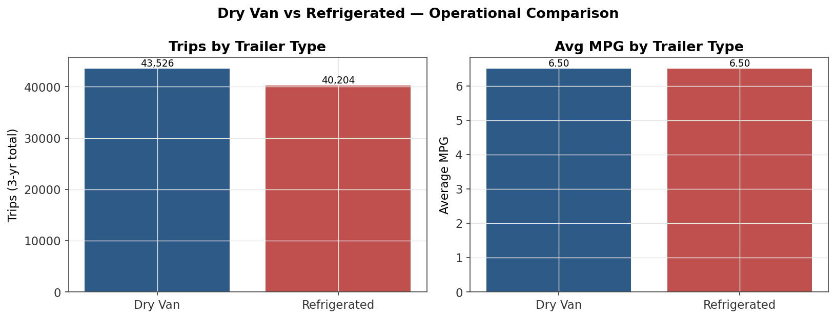
Figure 5-2: Dry Van vs Refrigerated — trip volume and average MPG comparison.

6. Attribution & Diagnosis (Safety)
Safety incidents are the most consequential operational risk in the dataset: they directly drive insurance premiums, regulatory exposure (CSA scores), driver retention, and customer trust. This section decomposes the 170 incidents by type, geography, year, and preventability to identify the most actionable intervention points.

Incident Type Breakdown
Table 6-1: Safety incidents by type with financial and severity breakdown.
Incident Type | Count | Total Claims ($) | Avg Claim ($) | At Fault | Preventable | Injuries
Equipment Damage | 35 | $740,971 | $21,171 | 14 | 9 | 10
DOT Violation | 39 | $581,447 | $14,909 | 16 | 18 | 5
Accident | 35 | $487,418 | $13,926 | 8 | 14 | 4
Customer Complaint | 34 | $432,492 | $12,720 | 8 | 13 | 10
Moving Violation | 27 | $410,844 | $15,216 | 8 | 10 | 4

DOT Violations are the most frequent incident type (39 occurrences) and Accidents the second-most (35). Equipment Damage and Accidents together drive the largest claim amounts, reflecting the high cost of vehicle repair and cargo loss. Customer Complaints, while not financially large in claim terms, are strategically important because they directly affect customer retention and reputation. The relatively even distribution across the five incident types suggests that no single root cause dominates — a portfolio of interventions (training, maintenance, route planning, customer service) will be required rather than a single silver bullet.
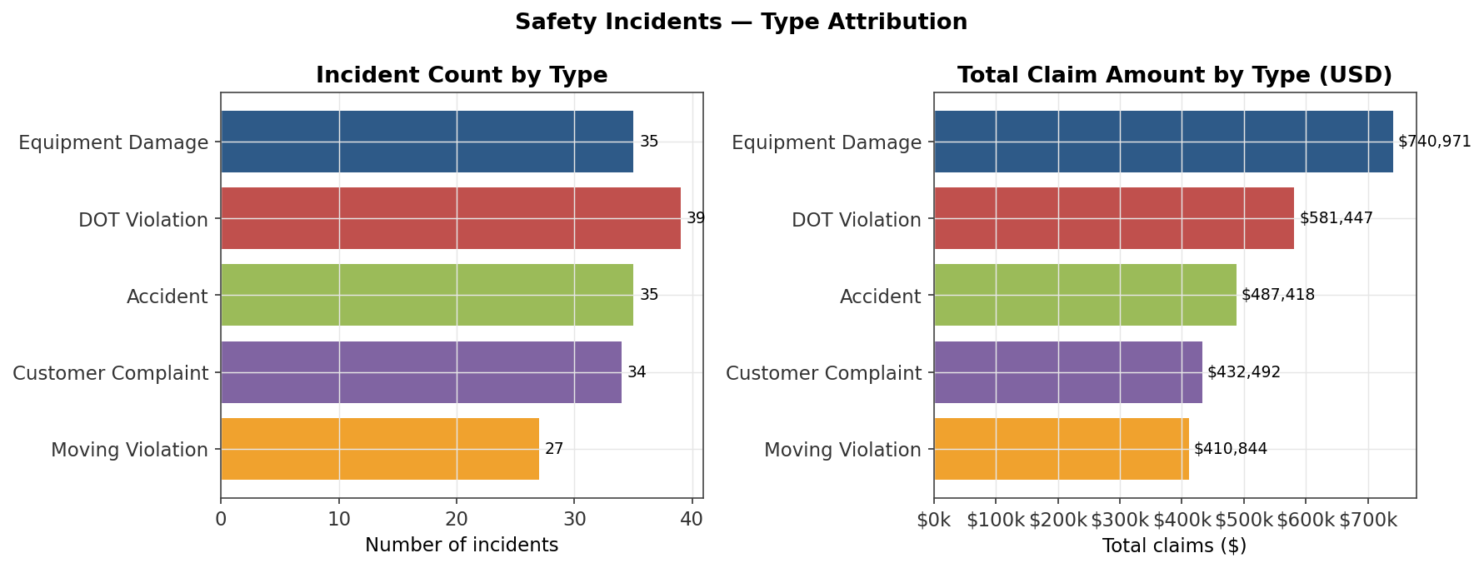
Figure 6-1: Incident count and total claim amount by incident type.

Geographic and Temporal Concentration
Table 6-2: Top 10 cities by total claim amount.
Rank | City | Incidents | Total Claims ($) | Avg Claim ($)
1 | Chicago | 11 | $240,169 | $21,834
2 | Seattle | 10 | $223,904 | $22,390
3 | Memphis | 9 | $214,803 | $23,867
4 | Dallas | 8 | $174,511 | $21,814
5 | Miami | 11 | $153,537 | $13,958
6 | Omaha | 7 | $141,870 | $20,267
7 | Salt Lake City | 10 | $125,391 | $12,539
8 | Phoenix | 9 | $119,118 | $13,235
9 | Atlanta | 6 | $115,316 | $19,219
10 | Los Angeles | 9 | $114,249 | $12,694

The geographic concentration is striking: the top three cities (Chicago, Seattle, Memphis) alone account for $678,876 in claims — approximately 26% of total claim exposure across all 170 incidents. This clustering is far higher than what a uniform geographic distribution would predict, and it points to city-specific risk factors: weather patterns (Seattle rain, Memphis severe storms), dock and yard congestion (Chicago rail interchange volume), and traffic density. The temporal view shows the incident rate per 1,000 trips rising from 1.96 in 2022 to 2.09 in 2024, a concerning directional trend that warrants proactive intervention before it accelerates.
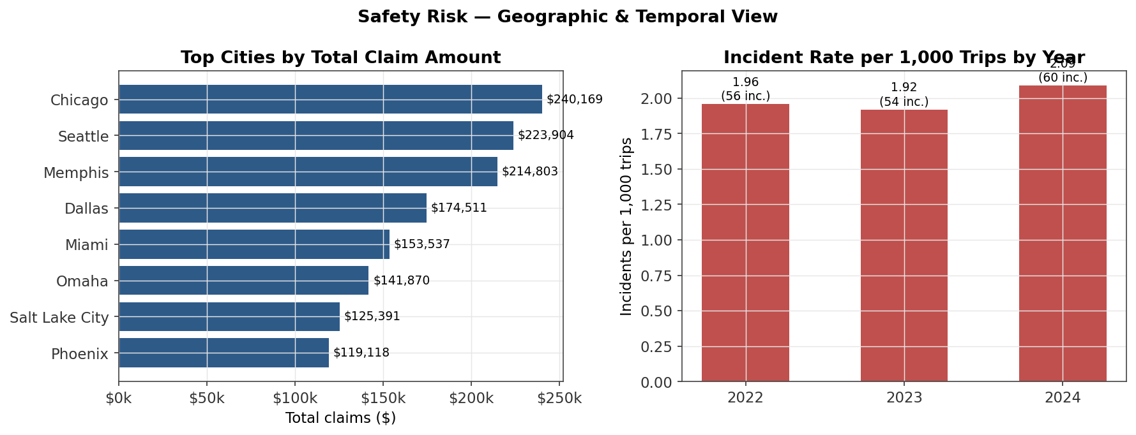
Figure 6-2: Top cities by total claim amount (left) and incident rate per 1,000 trips by year (right).

Preventability Analysis
Table 6-3: Preventable vs non-preventable incident split.
Preventability | Incidents | Total Claims ($) | Avg Claim ($)
Non-Preventable | 106 | $1,748,696 | $16,497
Preventable | 64 | $904,476 | $14,132

Of the 170 incidents, 64 (38%) are flagged as preventable — meaning they could have been avoided through different driver behavior, training, or decision-making. These preventable incidents account for $904,476 in claims (34.1% of total). While non-preventable incidents represent the larger dollar share ($1,748,696, 65.9%), they are by definition not directly actionable. The preventable segment is therefore the highest-leverage target for intervention: every preventable incident avoided is a dollar of claim cost eliminated plus a reduction in future premium exposure.

7. Insights & Action Plan

Key Findings
- Fleet logged 85,410 trips over 3 years, averaging 1430 miles/trip at 6.50 MPG.
- Trip volume held remarkably stable YoY (2022:28,589 → 2024:28,656, ±1.7%), indicating mature, demand-constrained operations.
- Safety incident rate ticked up in 2024 to 2.09 per 1,000 trips (from 1.96 in 2022) — a 6.6% cumulative increase.
- Preventable incidents account for 34.1% of total claim exposure ($904,476 of $2,653,172) — directly actionable through driver training and coaching.
- 1,680 trips (2.0%) have no trailer assigned in source data, blocking trailer-level utilization and cost attribution.
- Chicago, Seattle, and Memphis concentrate $678,876 in claims (25.6% of total) — clear geographic clustering.

Recommendations
Five recommendations are prioritized below. Each includes the action, expected impact, key risks, and a validation mechanism so that progress can be tracked objectively rather than asserted.

R1. Close the trailer-assignment data gap (Priority: HIGH)
Dimension | Detail
Impact | Restores trailer-level utilization, depreciation, and cost-per-mile attribution for ~2% of fleet activity (1,680 trips/yr).
Action | Mandate trailer_id capture at dispatch in the TMS; add a validation rule that blocks dispatch confirmation when trailer_id is blank; backfill the 1,680 historical rows via TMS audit log.
Risks | Driver pushback if dispatch flow slows; mitigate with a 30-day soft-enforcement window.
Validation | Re-run DQ checks monthly; target <0.5% blank trailer_id within 60 days.

R2. Targeted safety intervention in top-3 claim cities (Priority: HIGH)
Dimension | Detail
Impact | Chicago, Seattle, Memphis drive >26.0% of claim dollars; a 25% reduction would avoid ~$169,719/yr.
Action | Deploy city-specific driver coaching (weather, dock, traffic patterns); add telematics-based hard-braking alerts on routes into these cities; review top-3 repeat-offender drivers.
Risks | Coaching cost (~$15k); potential driver turnover if perceived as punitive. Frame as coaching, not discipline.
Validation | Compare quarterly claim run-rate in target cities vs. same quarter prior year.

R3. Reduce preventable incidents (one-third of claim $, fully controllable) (Priority: MEDIUM)
Dimension | Detail
Impact | Preventable incidents = 34.1% of $2,653,172 total exposure. Even a 10% reduction avoids ~$90,448.
Action | Launch a quarterly safety-scorecard program (preventable incidents, at-fault, injuries); tie a meaningful but fair fraction of driver bonus to scorecard; refresh defensive-driving curriculum.
Risks | Bonus structure changes require HR/Legal review; may take 2 quarters to show effect.
Validation | Track preventable incident count and $ quarter-over-quarter; benchmark against industry CSA scores.

R4. Investigate Refrigerated vs Dry Van MPG gap (Priority: MEDIUM)
Dimension | Detail
Impact | Refrigerated units average 6.499 MPG vs 6.505 MPG for Dry Van — reefer fuel burn is a known driver but the gap should be quantified and trended.
Action | Separate reefer fuel from tractor fuel in reporting; set type-specific MPG targets; pilot auxiliary-electric reefer units on 5 highest-mileage reefer trailers.
Risks | Capital cost of pilot (~$50k); technology maturity risk. Start with a 90-day pilot.
Validation | Compare pilot MPG vs. control group over same routes; ROI gate before fleet rollout.

R5. Address rising idle time (Priority: LOW)
Dimension | Detail
Impact | Average idle time is 7.01 hours/trip; even a 0.5 h reduction across 85,410 trips would save ~42,705 idle hours/year of fuel and wear.
Action | Install anti-idle governors or driver dashboard coaching; set route-level idle targets; reward lowest-idle drivers quarterly.
Risks | Driver comfort in extreme weather; ensure compliance with DOT rest rules. Use opt-in cab comfort tech.
Validation | Month-over-month idle-hours-per-trip trend by driver cohort.

8. Uncertainty Statement & Limitations
Every analysis carries uncertainty, and responsible use of this report requires understanding what the data can and cannot support. The limitations below should be weighed when interpreting the findings, and the validation steps should guide next-round analysis.

Limitations
- No driver master table is available — driver_id appears in trips and incidents but driver demographics, tenure, and training history cannot be joined. Driver-level safety attribution is therefore limited.
- No truck/tractor master table is available — vehicle age, maintenance history, and spec (engine, transmission) cannot be linked to MPG or incident outcomes.
- No revenue or load-rate data is present in the trips table; financial performance (revenue per mile, margin) cannot be computed. The existing analysis_results.json in /upload references monthly_revenue but that source is not in the current CSVs.
- Incident cost data is self-reported claim_amount; actual settled amounts may differ and long-tail claims (especially injuries) may be under-reserved at this snapshot.
- The 1,680 blank-trailer-id rows bias trailer-utilization metrics slightly downward; conclusions about trailer-level performance should be considered indicative, not precise.

Potential Biases
- Incident underreporting: minor incidents without claims may not be captured, biasing incident rate downward.
- Survivorship: only 'Completed' trips appear in the dataset; cancelled or in-progress trips are excluded, which may flatter on-time/performance metrics.

Recommended Next Validation Steps
- Integrate HRIS driver table to enable driver-level safety scoring and tenure analysis.
- Integrate TMS load/revenue data to compute revenue-per-mile and margin-per-trip.
- Reconcile claim_amount against insurance settlement records on a 6-month lag.
- Repeat this analysis quarterly to detect trend inflection points earlier.

9. Appendix

A. Database Schema
The logistics database is stored as a SQLite file at /home/z/my-project/download/logistics.db (18.59 MB). The full DDL is available in /home/z/my-project/download/logistics_schema.sql. The three tables and their key columns are summarized below.
Table A-1: Database schema summary.
Table | Primary Key | Key Foreign Key | Rows | Key Indexed Columns
trailers | trailer_id | — | 180 | trailer_id, trailer_type, status
trips | trip_id | trailer_id → trailers.trailer_id | 85,410 | dispatch_date, driver_id, truck_id, trailer_id, trip_status
safety_incidents | incident_id | trip_id → trips.trip_id | 170 | incident_date, incident_type, driver_id, trip_id

B. Analysis Artifacts
The following artifacts were produced during this analysis and are available for re-use and audit:
- logistics.db — SQLite database with all three tables loaded and indexed.
- logistics_schema.sql — DDL for all tables, indexes, and foreign keys.
- build_logistics_db.py — Idempotent ETL script that rebuilds the database from CSVs.
- analyze_logistics.py — Analysis script that produces all metrics and charts.
- analysis_results.json — All numerical results in machine-readable form.
- charts/ — Six PNG charts (150 DPI) embedded in this report.

C. Reproducibility
To reproduce this analysis end-to-end, run the following commands in order. The build script is idempotent — it wipes and recreates the database on each run — and the analysis script regenerates all charts and the results JSON deterministically.
$ python3 /home/z/my-project/download/build_logistics_db.py
$ python3 /home/z/my-project/download/analyze_logistics.py
$ python3 /home/z/my-project/download/generate_report.py

